HIV Trends Analysis

**Using PowerBI**

**HIV Cases by Period and Region (Line Graph)**

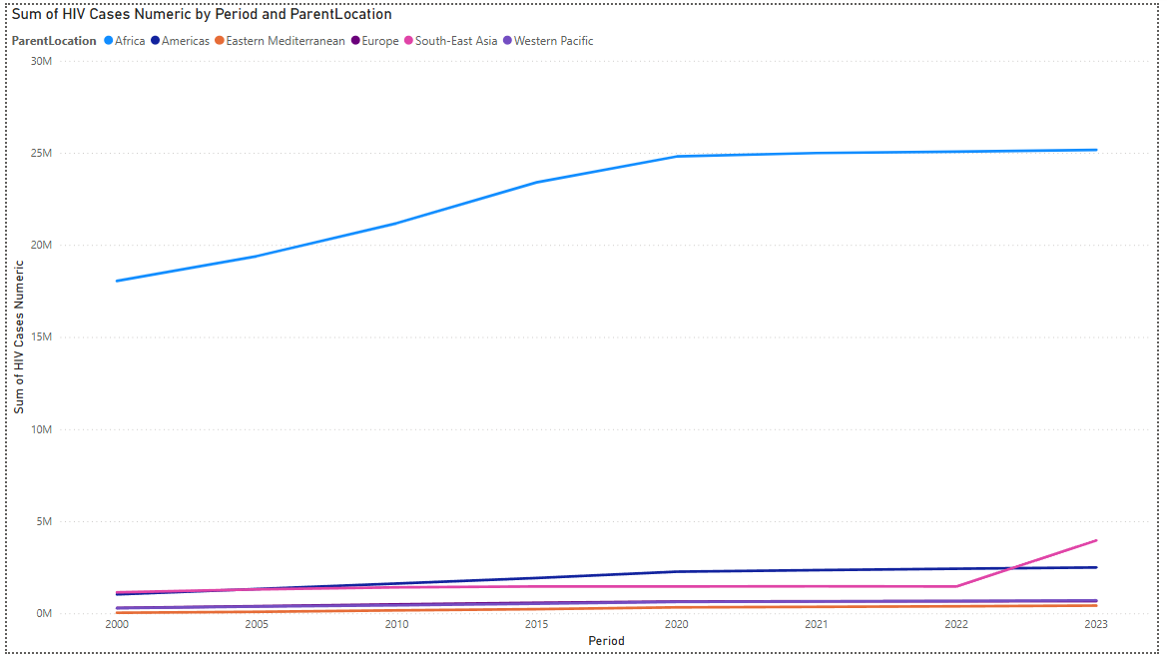

This line graph tracks HIV case numbers over time from 2000 to 2023, broken down by WHO region:

* **Africa** (blue line) shows the highest case numbers throughout the entire period, starting at approximately 18 million cases in 2000 and rising steadily to about 24-25 million by 2020, after which it plateaus through 2023.
* **All other regions** maintain relatively low case numbers (under 5 million) throughout the entire period.
* **South-East Asia** (pink line) shows a notable surge between 2022 and 2023, rising more steeply than any other region in that final year.
* **The Americas** (dark blue line) shows a gradual increase over the 23-year period.
* The overall trends suggest that while Africa's HIV epidemic has stabilized in recent years, South-East Asia may be experiencing a new phase of increased cases.

**Geographic Distribution of HIV Contribution (Map)**

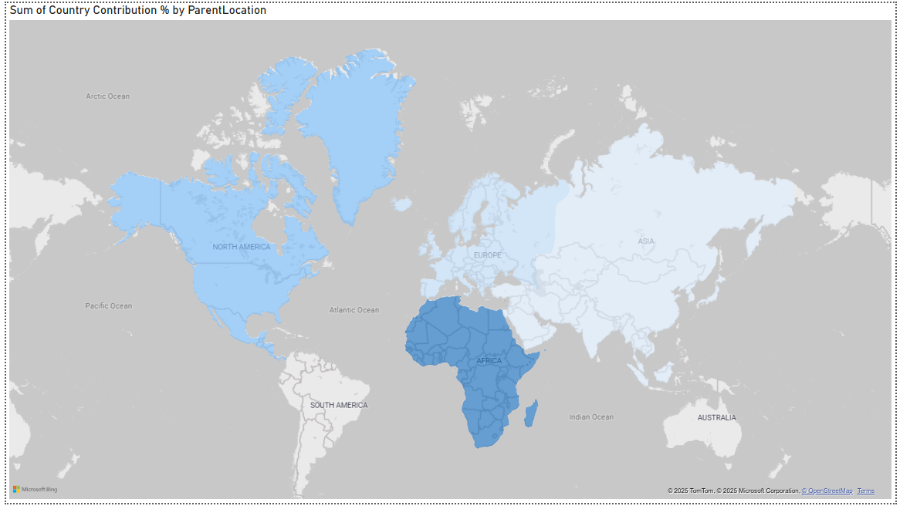

The world map visualization reinforces the findings from the other charts:

* Africa is highlighted in darker blue, visually emphasizing its position as the region most severely affected by HIV.
* Other continents appear in much lighter shades, reflecting their significantly smaller contributions to global HIV cases.
* The map helps contextualize the geographic concentration of the HIV epidemic, showing how the disease burden is not equally distributed across the world but rather heavily concentrated in sub-Saharan Africa.
* This geographic visualization makes the disparity immediately apparent in a way that complements the more detailed statistical breakdowns in the other charts.

**Country Contribution by Region (Pie Chart)**

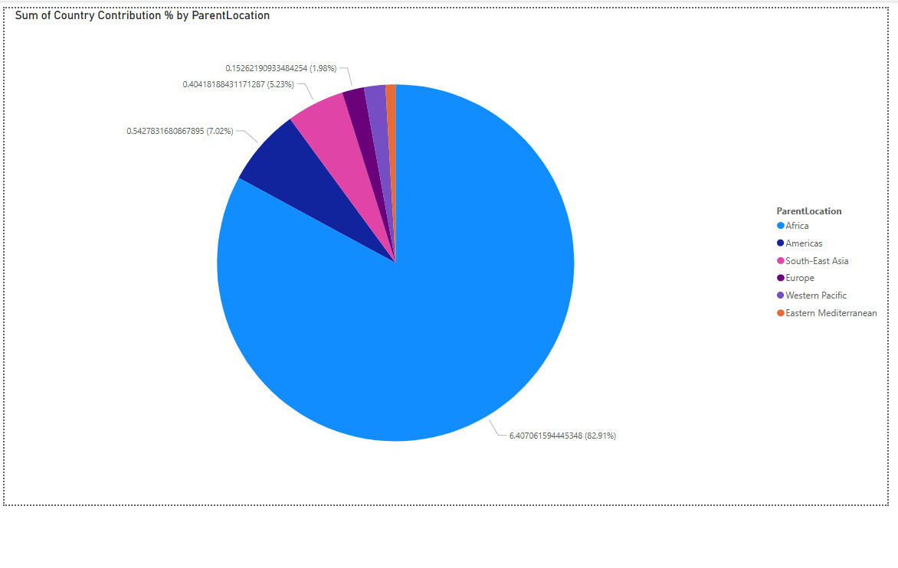

This pie chart provides a clear breakdown of the global HIV burden by region:

* **Africa bears an overwhelming 82.91% of the global HIV burden**, represented by the dominant blue section that occupies most of the pie chart.
* **The Americas** account for the second largest share at 7.02%, a distant second to Africa.
* **South-East Asia** contributes 5.23% of global HIV cases.
* **Europe, Western Pacific, and Eastern Mediterranean** regions collectively account for less than 5% of global HIV cases, with Europe at 1.96% and Eastern Mediterranean showing the smallest contribution.
* This visualization starkly illustrates the disproportionate impact of HIV on the African continent compared to all other world regions combined.

**HIV Cases by Multidimensional Poverty Headcount Ratio and Region**

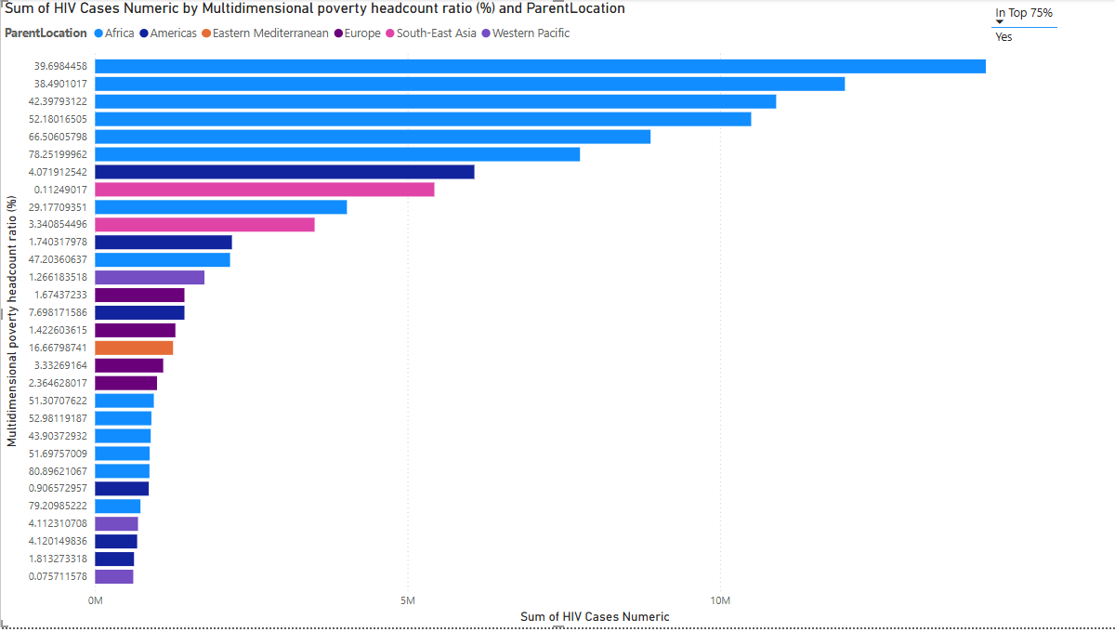

The image shows a bar chart depicting the sum of HIV cases across different regions, organized by multidimensional poverty headcount ratio percentages. These visualizations reveal:

* **Africa dominates HIV case numbers** across nearly all poverty headcount ratio categories, with the highest bars consistently shown in blue. The regions with the highest HIV case counts (approaching 10M cases) are associated with poverty headcount ratios ranging from approximately 39-78%.
* **South-East Asia** (shown in pink) has a significant number of cases concentrated around the 0.11% poverty headcount ratio, suggesting a different pattern than Africa where cases correlate more strongly with higher poverty ratios.
* **Other regions** including the Americas (dark blue), Europe (purple), Western Pacific (light purple), and Eastern Mediterranean (orange) show considerably lower HIV case numbers compared to Africa, regardless of poverty headcount ratio.
* The visualization suggests a strong correlation between multidimensional poverty and HIV prevalence, particularly in Africa, where the highest case counts align with higher poverty ratios.